Explore – Part I: The sheep pluck dissection – Lungs NAMES: ________________
SAFETY: Take care with sharp dissecting tools. Observe careful hygiene precautions after the dissection.
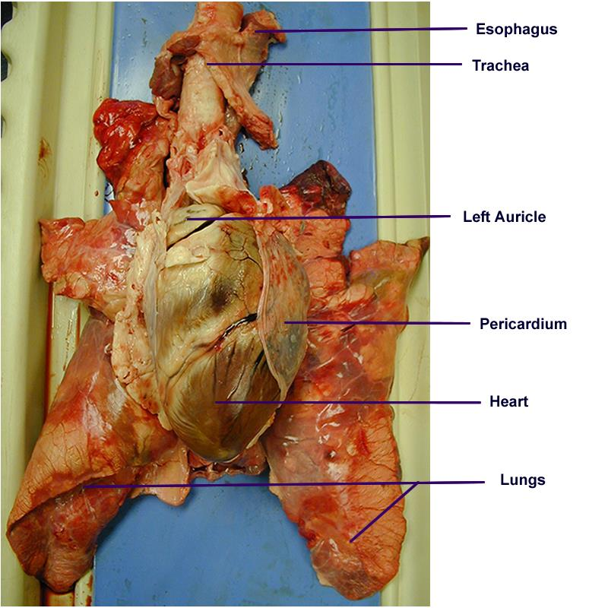
1. Note the general shape and size, color and texture of the lungs.
2. Locate the following on your specimen. Use your textbook for help. Make the cuts as indicated. Answer the questions in italics.
- Esophagus – this is the “food tube”. Where is it located compared to the trachea? ______________________________
• Trachea – the main tube bringing air into and out of the lungs.
- Epiglottis – look down the larynx and find the epiglottis. Move the epiglottis to demonstrate how it functions in the respiratory system. What does it feel like? _______________________________________________
• Cartilaginous hoops (“C” rings) in the trachea – these are horseshoe-shaped and keep the trachea open for the passage of air, but allow the tube to bend and flex easily.
• Larynx (if it is present) – Also known as the “voice box” and includes thyroid, cricoid, epiglottis, arytenoids cartilages. The thyroid cartilage in men is also called the Adam’s apple. How is the structure different from the trachea? ________________________________________________________________________________
• If the larynx is still attached to your lungs, try forcing air through the larynx while you squeeze it tight. As air moves past the skin and cords in the larynx it may make a noise. Discuss how similar this is to the noise the animal makes in life.
• Pleural membrane – this is a thin layer of connective tissue covering the whole of the lungs.
• Lobes of the lung - How does the surface of the lung feel? How many lobes are on each side?___________________ ________________________________________________________________________________________________
• Inferior to the larynx and superior to the Hilus of the Lungs, make a cross section (transverse cut) through the trachea by cutting between 2 cartilage rings. Examine the lumen.
• Follow the trachea down into the lungs and locate the spot where it splits into 2 branches.
• Define bifurcation. How does it relate to lung structure? ____________________________________________________
• Locate the Carina (a ridge at the base of the trachea) of the trachea. Describe its location. ___________________________
• Primary bronchi – the right bronchus leads from the trachea to the right lung and the left bronchus to the other lung. How do they differ from the trachea? Where is this branching in relation to the heart? __________________________
• First bronchioles – these are the finer tubes dividing off the bronchi. See if you can continue to follow the branching into secondary and tertiary bronchioles. Why do the bronchioles contain smooth muscle? What happens to the smooth muscle of a person with asthma? _____________________________________________________________________________
3. Inflate the lungs. Insert a large bubble tea straw or rubber tubing here you made an incision in the trachea. Try to exhale (don’t breathe in!) and see how much of the lungs you can inflate. What do they look like inflated compared to when they are at rest? _____________________________________________________________________________
4. The lungs are made of spongy lung tissue. Examine them more closely. Cut off a piece of lung and drop it into a beaker of water. Observe what happens? ______________________________________. What does this indicate about the lungs and the tissue? _________________________________________________________________________________________
5. Go back to the trachea incision and make a longitudinal cut all the way down the trachea. Follow this incision into the branches of the lungs and identify the respiratory tree. What do you notice about the similarities and differences in the bronchi and bronchioles as you move deeper into the lungs? _____________________________________________________________________________
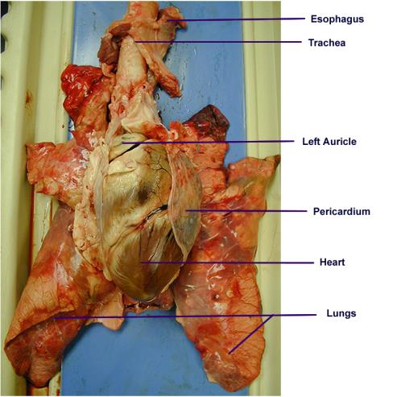
Explore–Part II: The sheep pluck dissection-Heart
- Before starting the dissection of the heart, identify, or tentatively identify the following structures:
Blood vessels: A. Aorta B. Superior vena cava C. Inferior vena cava D. Pulmonary artery
E. Coronary arteries F. Coronary veins G. Pulmonary vein
Chambers: A. Right atrium B. Left atrium C. Right ventricle D. Left ventricle
Structures: A. Base of heart B. Apex of heart C. Pericardium
- Any vessels linking the lungs to the heart. Arteries have thick, rubbery walls. Veins have much thinner walls. Feel inside these vessels with your fingers and feel the texture and strength of both vessels. Try to describe what you feel. Identify the pulmonary veins, pulmonary arteries, aorta, and bronchial blood vessels. _________________________________
________________________________________________________________________________________________
________________________________________________________________________________________________
• Pericardium – this is a layer of tissue surrounding the heart. Cut into it. How does it feel? ______________________
• Thymus gland – lies above the heart. What is its function? ________________________________________________
- Right Side of Heart - Use the scalpel for making incisions. Make an incision with the scalpel from the superior vena cava to the apex of the heart. This incision exposes the interior of the superior vena
cava, the right atrium, the tricuspid valves, and the right atrium.

- Observations -
Notice the difference in the color, structure, and thickness of the walls
of the right atrium and the right ventricle. Identify the tricupsid and the chordae tendinae and papillary muscles. Identify the three layers of the ventricular wall: the thin outer epicardium, the very thick middle myocardium, and the thin inner endocardium.

- Pulmonary artery/veins - Locate the opening of the pulmonary artery at the junction of the right atrium and the right ventricle
Cut along the artery with the Scalpel and observe. ________________________________

- Left heart - Cut along The Pulmonary Vein to the apex.

- Posterior Heart (Back side)
Observations - Notice the difference in the size, location, thickness of the wall of the left ventricle with reference to the right ventricle. ________________________________

- Locate the bicuspid valve. The left ventricle is much larger in size, centrally located, and the wall is much thicker (about twice) than that of the right ventricle. Why? ________________________________

- Identify the interventricular septum that separates the two ventricles. Locate the opening of the aorta at the junction of the atrium and the ventricle. Notice of cusps of the aortic semilunar valve of the aorta. ________________________________

- Notice just above the valve cusps the exits for the left and right coronary arteries. ________________________________

